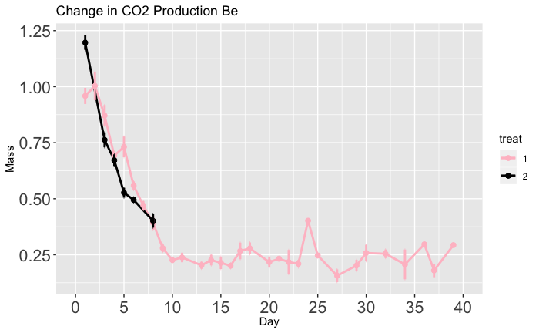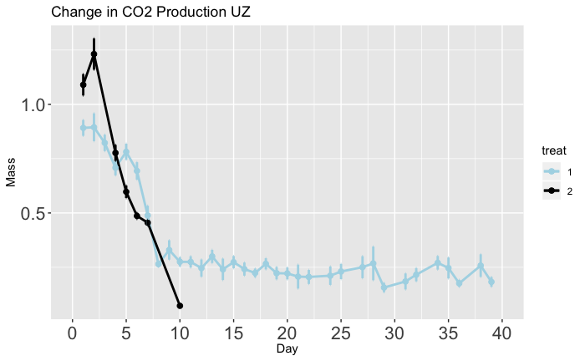

B

1.25

1.00

0.75

0.50

0.25

1.0

0.5

0 5 10 15 20 25 30 35 40

Time (days)

0 5 10 15 20 25 30 35 40

Time (days)

A

CO2 Production (µ/g/min)

(Short-Diapause Genotype)

\*

Diapause Programming

Non Diapause

CO2 Production (µ/g/min)

(Long-Diapause Genotype)

Diapause Programming

Non Diapause

\*